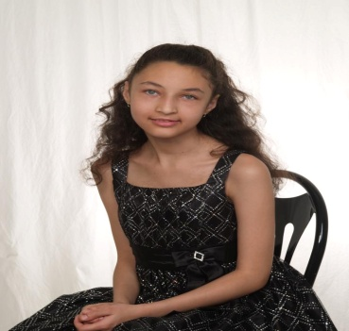
Kickin it for Koryn!

Imagine a life of suffering from paralysis in your limbs and face affecting swallowing that you are hooked up to a machine to get the nutrients you need, on oxygen to help your breathe, seizures, painful dystonia’s and chronic migraines. Imagine a life where water, wind, sun, stress, pain, playing, and excitement trigger paralysis in your body.
Alternating Hemiplegia of Childhood is a rare neurological condition that only a little over 200 children in the world suffer from. There is no treatment and no cure.
This is our time to make a difference for Koryn and other children like her. For just a donation at the door includes food and entertainment. There will be raffles and a silent auction. All proceeds go to the AHC Foundation.
Make a difference today!
May 27, 2012
Hummelstown Fire Hall
From 2pm – 6pm

