Instructions: Modify the letter below to suite your needs. Insert a picture of your AHC kid if you like. (Use text wrapping to let the words flow around the picture.) Delete italic text before printing.
Example text to be modified by each person:
Dear friends and Family
Our child __________________ suffers from AHC (Alternating Hemiplegia of Childhood; a rare condition for which there is not a cure or treatment. That is all about to change! With your help, we can fund a promising gene therapy project that may result in a cure for our child. During the month of April, a generous donor has come forward to challenge the AHC community. They are matching 50 THOUSAND DOLLARS on donations in April!
How you can Help:
Donate through AHCkids.org during the month of April.
Donate by mail by sending a check to:
Alternating Hemiplegia of Childhood Foundation
2000 Town Center Suite 1900
Southfield, MI 48075
Spread the word on social media.
Like the AHC kids Foundation Facebook page and
share the updates with your networks.
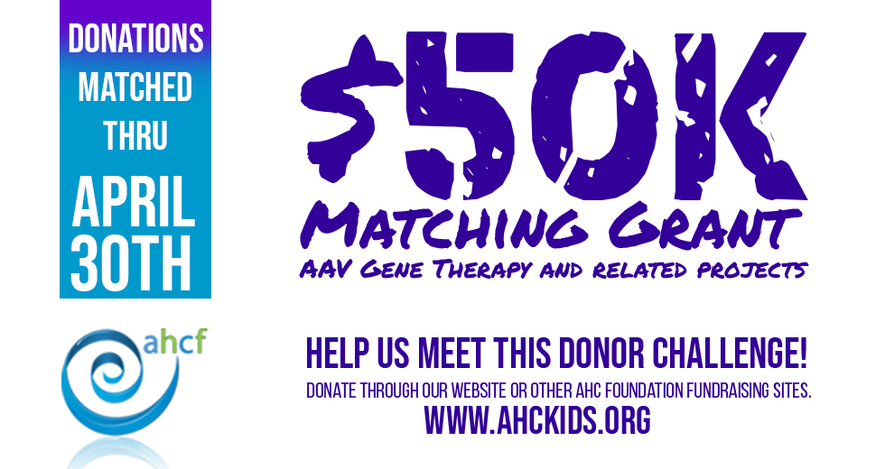
Learn more about Alternating Hemiplegia of Childhood at www.ahckids.org

